1. Class Variable & Instance Variable
2. Regular Methods, Class Methods and Static Methods:

Regular methods automatically take instance as first argument (self).

To make a method take class as the first argument, we use ClassMethod.

Static Method is independent of class and instance.

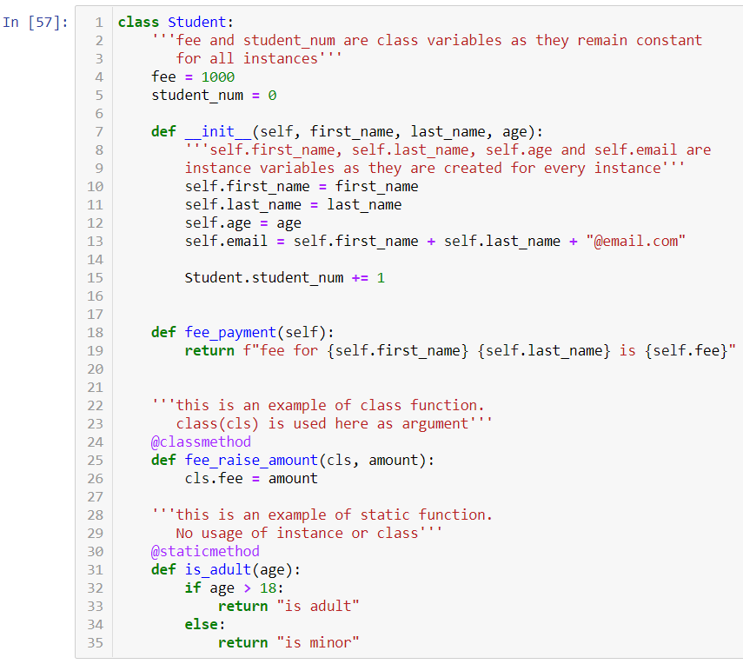

1. Class Inheritance Example:

Inheriting parent class Employee and forming Subclass Developer

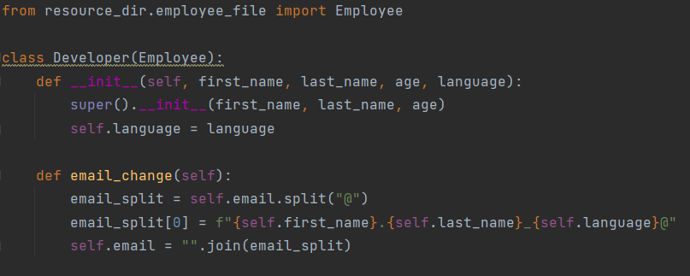



1. To convert a method into an attribute, use @property as decorator